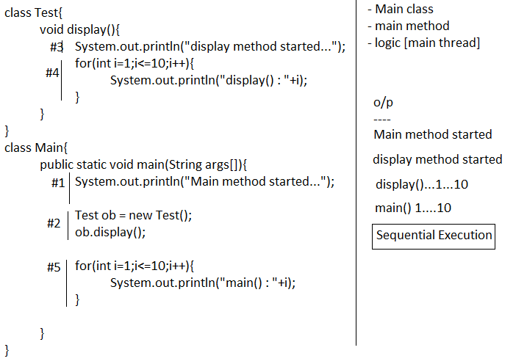
Multithreading
- Executing different parts of the program simultaneously is called multithreading.
- Thread is the separate path of sequential execution.
- The main advantage of multithreading is to improve the CPU utilization. Hence execution speed will be increased and response time will be decreased.
Main Thread
- When a java program started one thread is running immediately that thread is called main thread.
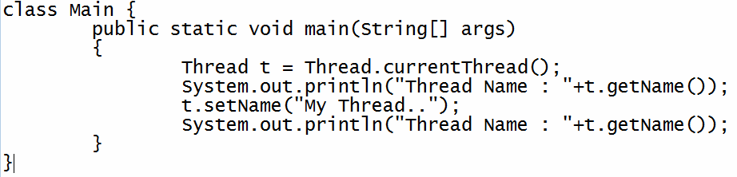

Different ways to create thread
- By extending Thread class
- By implementing Runnable interface
Internal of Thread Class and Runnable Interface
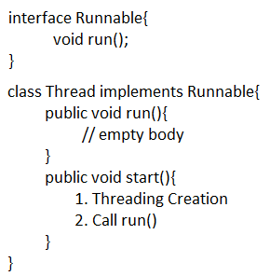
By extending Thread class
- Create a class by extending Thread class.
- Override the run() method to write the logic of the thread
- Create user defined thread class object
- Start thread by calling start() method of Thread class

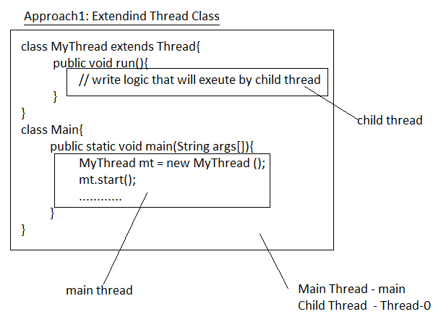
Example
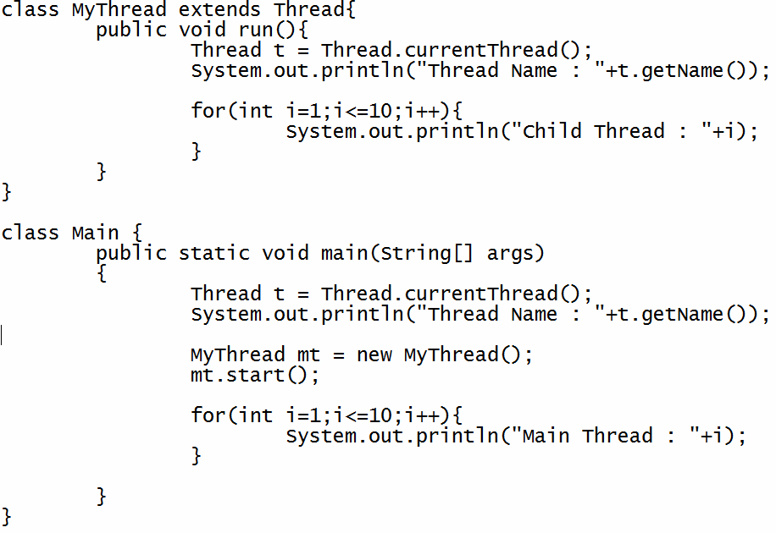
By implementing Runnable Interface
- Create a class by implementing Runnable interface.
- Override the run() method to write the logic of the thread
- Create user defined thread class object
- Creates a Thread class object
- Start thread by calling start() method of Thread class

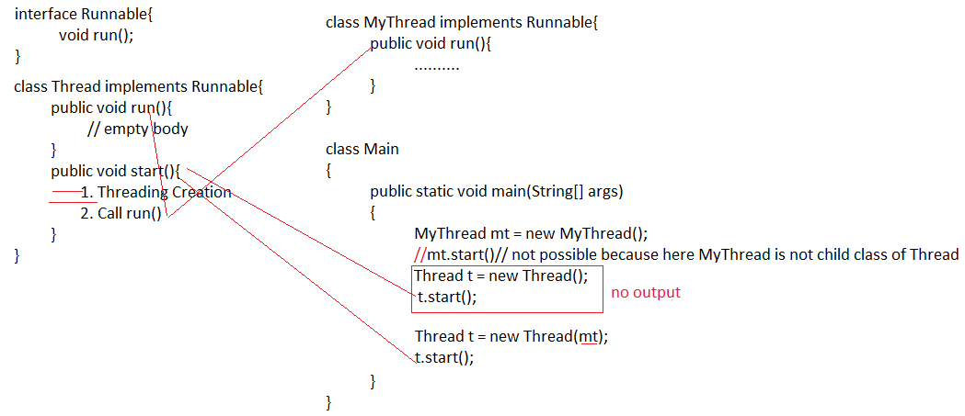
Example
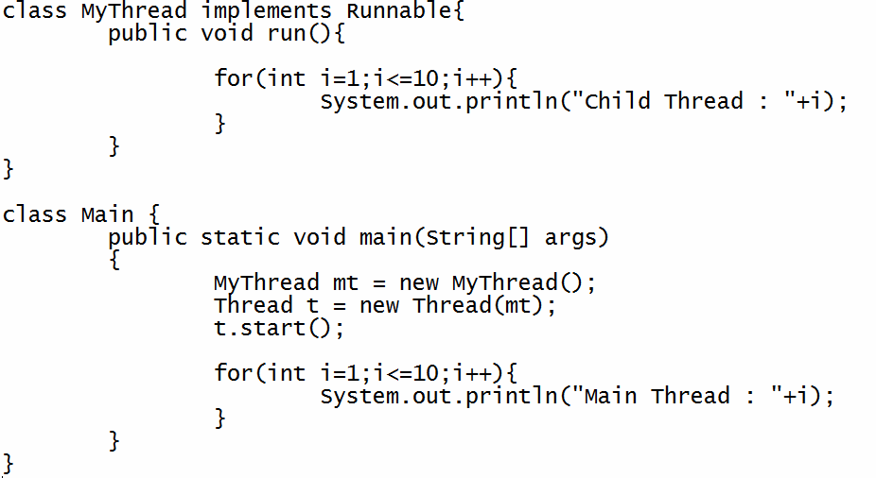
Thread Priorities
- The valid range of thread priorities is 1 – 10. Where one is lowest priority and 10 is highest priority.
- The default priority of main thread is 5. The priority of child thread is inherited from the parent.
- Three constant values for the thread priority.
MIN_PRIORITY = 1
NORM_PRIORITY = 5
MAX_PRIORITY = 10
Example
class MyThread extends Thread
{

public void run()

{

Thread t = Thread.currentThread();
System.out.println("Child Thread : "+t.getPriority());
}

}
class Main{

public static void main(String arg[])

{
Thread t = Thread.currentThread();
t.setPriority(10);
System.out.println("Main Thread : "+t.getPriority());

MyThread mt = new MyThread();
mt.setPriority(5);

mt.start();

}

}

Preventing Thread from execution
- We can prevent a thread from execution by using the following methods.
  - sleep()
  - join()

sleep()
- If a method has to wait some predefined amount of time with out execution then we should go for sleep() method.
Example
class MyThread extends Thread{
public void run(){
for(int i=1;i<=50;i++){
System.out.println("Child : "+i);
}
System.out.println("End of child thread");
}
}
class Main{
public static void main(String args[]){
MyThread mt = new MyThread();
mt.start();

for(int i=1;i<=5;i++){
System.out.println("Main : "+i);
}

try{
Thread.sleep(5000);
}catch(Exception e){
System.out.println("Error : "+e);
}

System.out.println("End of main thread");
}
}

Join()
- If a thread wants to wait until some other thread completion then we should go for join method.
Example
class MyThread extends Thread{
public void run(){
for(int i=1;i<=50;i++){
System.out.println("Child : "+i);
}
System.out.println("End of child thread");
}
}
class Main{
public static void main(String args[]){
MyThread mt = new MyThread();
mt.start();

for(int i=1;i<=5;i++){
System.out.println("Main : "+i);
}

try{
mt.join();
}catch(Exception e){
System.out.println("Error : "+e);
}

System.out.println("End of main thread");
}
}

Life cycle stages
- New
- Ready
- Running state
- Blocked / waiting
- Dead state

New

MyThread mt = new MyThread();

Ready

mt.start();

Running State

- If thread scheduler allocates CPU for particular thread.
- Thread goes to running state.
- The Thread is running state means the run() is executed.

Blocked State

- If the running thread got interrupted of goes to sleeping state at that moment it goes to the blocked state.

Dead State

- If the business logic of the project is completed means run() over thread goes dead state.

